August 10, 2020

Dear Tribal Leader,

I write to cordially invite you to attend the 2020 Covered California Tribal Consultation. This Consultation will provide an opportunity for Tribal and Covered California officials to collaboratively discuss the implementation of the unique benefits American Indians and Alaska Natives receive under the federal law, and for Covered California to hear about issues of importance to our state’s Tribes.

Covered California’s Tribal Consultation is scheduled for:

October 12, 2020
1:00PM-5:00PM
Remotely by Webinar

In recognition of the unprecedented COVID-19 pandemic we are facing, this year’s Consultation will be held remotely by webinar only. For more information or to register for this event, please email tribalconsultation@covered.ca.gov.

Covered California is committed to strengthening and sustaining an effective government-to-government relationship with California Tribes through a meaningful consultation process. Thank you and we look forward to seeing you on October 12th.
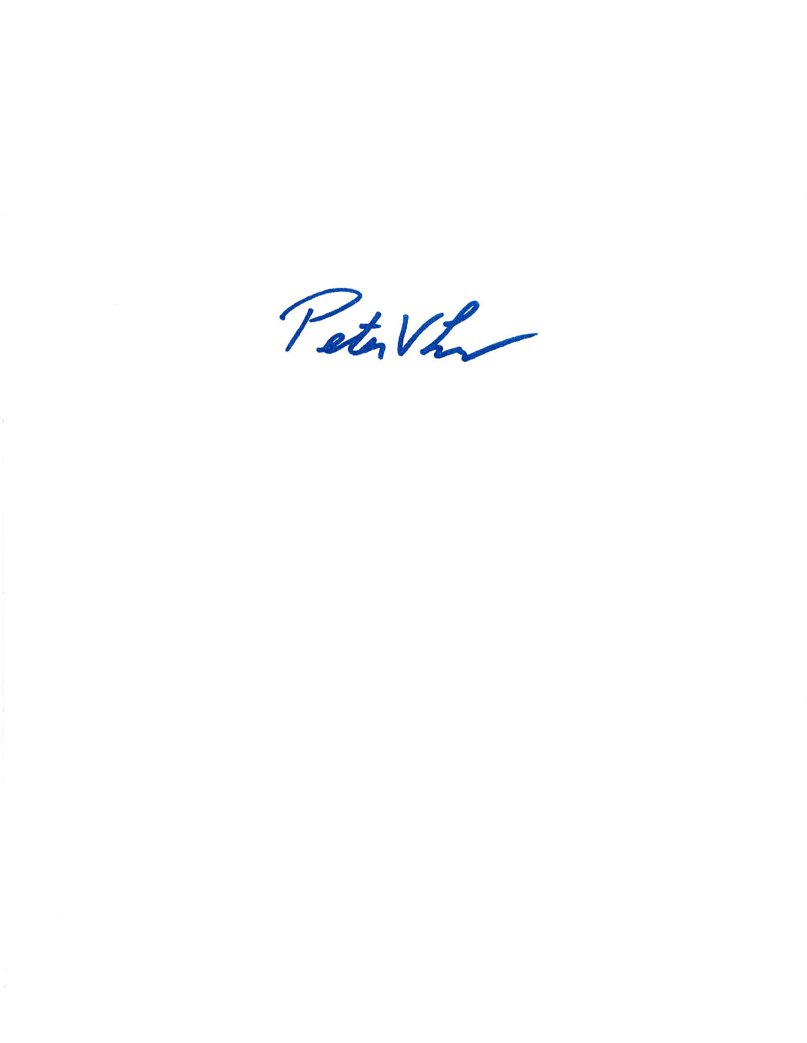
Sincerely,

Peter V. Lee
Executive Director

